Nirmal Patel Data Cleaning R

#will be used to filter data

library (dplyr)

library (tidyr)

#easy way for me to find where my data is stored

refine<-read.csv(file.choose(),header=T)

#i can see the raw data

refine

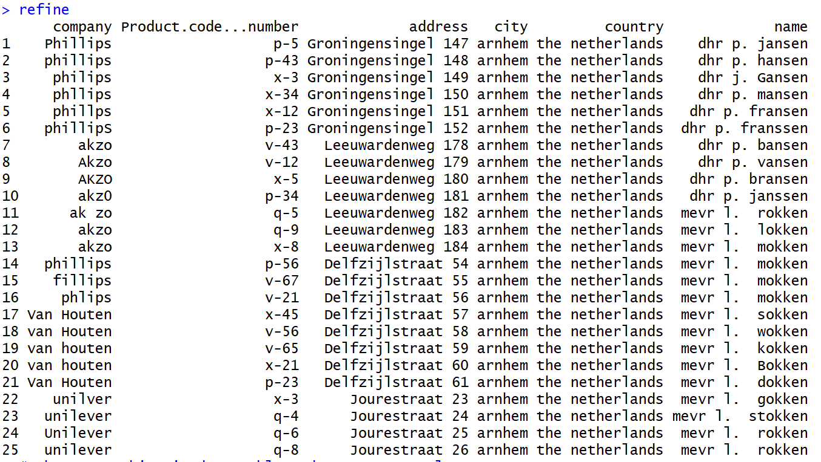

#makes everything in data table under company to lowercase

refine_lower<-mutate (refine, company=tolower(company))

refine_lower

#this gives the the different types of names i will have to make into 4

distinct(select(refine_lower, company))

unique(refine_lower$company)

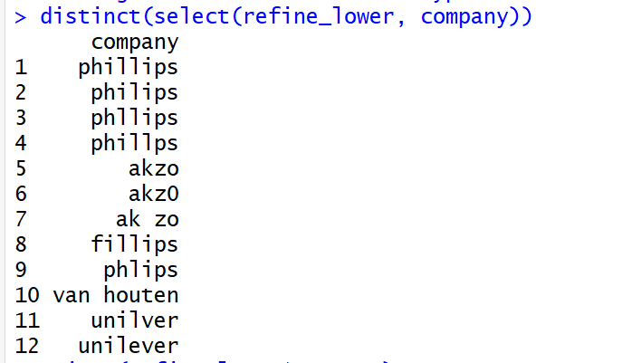

#refines the names into similar names for the same company (<http://astrostatistics.psu.edu/su07/R/html/base/html/grep.html>)

refine_lower$company <- gsub(glob2rx("*ps*"),"phillips",refine_lower$company)

refine_lower$company <- gsub(glob2rx("*ak*$"),"akzo",refine_lower$company)

refine_lower$company <- gsub(glob2rx("*van*$"),"van houten",refine_lower$company)

refine_lower$company <- gsub(glob2rx("*uni*$"),"unilever",refine_lower$company)

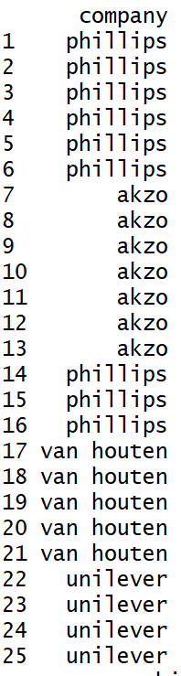

#YES We have to made it into 4

distinct(select(refine_lower, company))

# Seperate product_code and product_number

refine_lower <- refine_lower %>% separate(Product.code...number, c("product_code", "product_number"), sep = "-")

# We are makeing names of the product categories

temp_prodcodes <- c("p","x","v","q")

temp_categories <- c("Smartphone", "Laptop", "TV", "Tablet")

temp_df <- tbl_df(data_frame(temp_prodcodes, temp_categories))

print(temp_df)

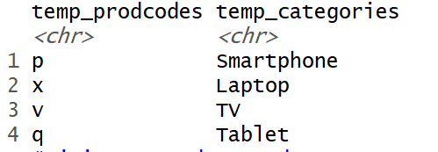

# join on product code

refine_lower <- inner_join(refine_lower, temp_df, by = c("product_code" = "temp_prodcodes"))

refine_lower

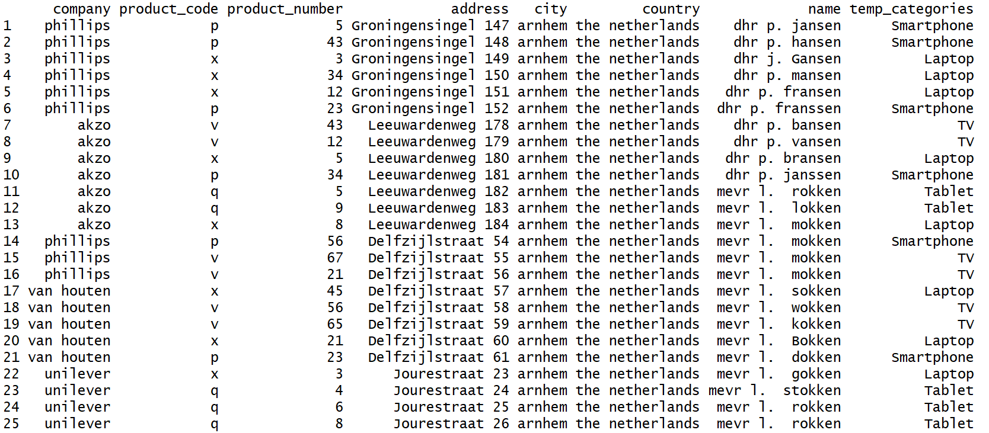

# rename temp_categories column

refine_lower <- rename(refine_lower, product_category = temp_categories)

#4: Add full address for geocoding by address, city, country

refine_lower$full_address<- paste(refine_lower$address,refine_lower$city,refine_lower$country, sep=",")

refine_lower

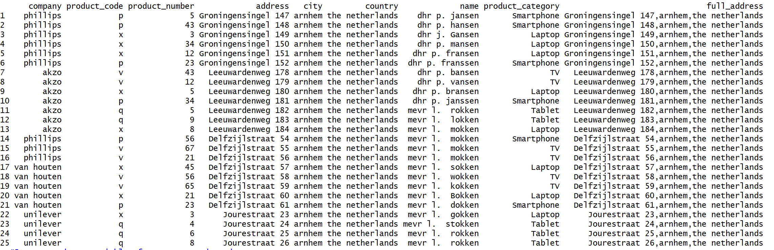

#5: Create dummy variables for company and product category

refine_lower <-refine_lower %>% mutate(company_phillips = ifelse(company == "phillips", 1, 0),

company_akzo = ifelse(company == "akzo", 1, 0),

company_van_houten = ifelse(company == "van houten", 1, 0),

company_unilever = ifelse(company == "unilever", 1, 0),

product_smartphone = ifelse(product_category == "Smartphone", 1, 0),

product_tv = ifelse(product_category == "TV", 1, 0),

product_laptop = ifelse(product_category == "Laptop", 1, 0),

product_tablet = ifelse(product_category == "Tablet", 1, 0))

refine_lower

